- Access request form here: Additional Compensation DocuSign.

**After the initiator opens the link (above or from HR webpage), they will be able to enter the details of the request. **

- Initiator information: this will be the name of the chair/supervisor completing the form for their employee.
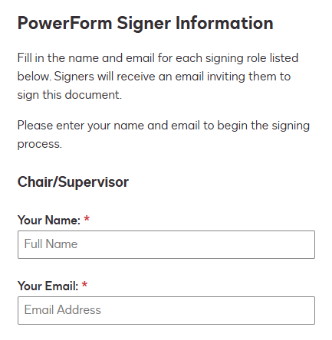

- Employee information: this will be the name of the employee receiving additional compensation.
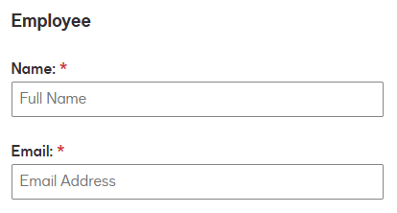

- Names for Dean/Director, College/Division Administrator, and Vice President (or designee) will follow.
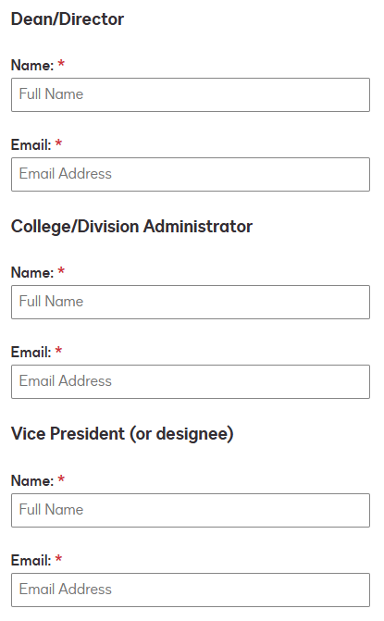

- Initiate the form by clicking Begin Signing.
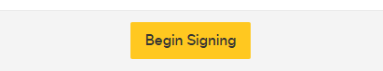

- If the Electronic Record and Signature Disclosure appears, check the box to acknowledge.
Click Continue.
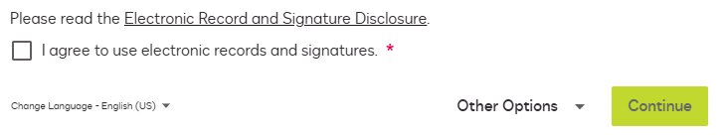

Please follow the instructions to complete the form:

- Click Continue to begin.
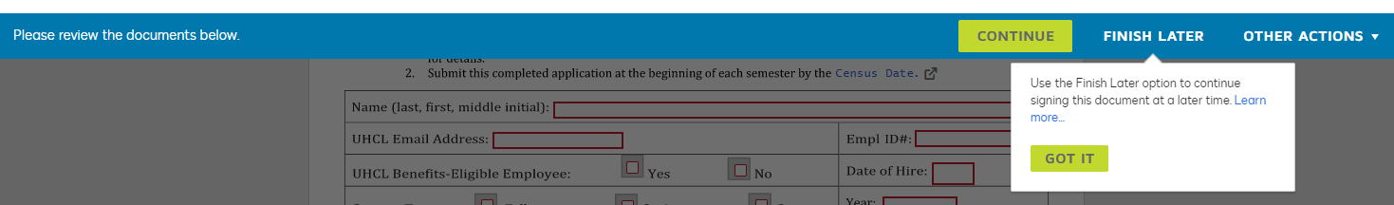

- Complete the required fields for the employee receiving additional compensation and sign. Please note that the service must be performed outside of normal working hours.
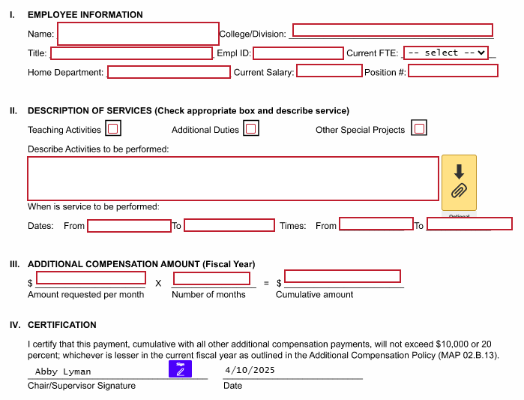

- When finished, click the Finished button at the bottom of the screen. The document will be routed for signatures.


- After all departments have signed the form, HR will send the final signed copy to the C/DBA for processing.

