Point-Tilt-Zoom (PTZ) Camera Overview

As we near the start of the 2021-2022 academic year, OIT staff are equipping general classrooms as quickly as possible with Ultra-HD conferencing cameras (Rally or similar) and ceiling-mounted microphones. Given the shortage of microchips due to the pandemic, camera supply issues may prevent every classroom being fully equipped by August 23. We will post and update our classroom inventory spreadsheet on the Office of Information Technology's landing page. This document will review the essential operation of these new point-tilt-zoom (PTZ) classroom cameras.

What is a PTZ Camera?
PTZ is simply an acronym for point-tilt-zoom. Instructors in PTZ camera-equipped classrooms can move the camera left or right (pan), up or down (tilt), and closer or farther (zoom). Instructors can operate the camera's PTZ controls using the touchscreen panel near the teaching workstation.
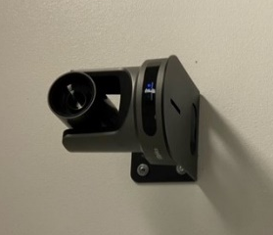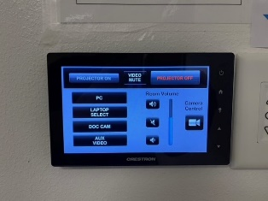
Figure 1. PTZ Camera in the back of Bayou 1104 Figure 2. Crestron Touchscreen Panel

What Does It Do?
The PTZ cameras enable instructors to record or live stream class meetings and lectures with Zoom or Echo360.
Zoom. When recording or live streaming a class with Zoom, whatever the PTZ camera shows is what remote participants will see as your Zoom video feed. If you also share your computer screen in Zoom, remote participants can toggle between the PTZ camera view and the shared screen content view.
In the following image from a Zoom participant's iPhone, the PowerPoint being shared by the instructor is in full-screen view. However, the student can click or pin the classroom image (from the PTZ camera) in the upper right corner as the full-screen image on their device.
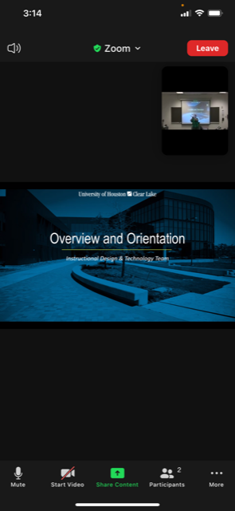
View of the classroom through the PTZ camera.
Instructor's shared PPT
Figure 3. Zoom session - iPhone
Echo360. Using Echo360, configured to display both the PTZ camera signal and the computer desktop, remote learners will see a side-by-side configuration. However, students can also hide one to focus on the other and then toggle between the two views.
Zoom v. Echo360 - Which to Use? Two issues should guide your choice. First, consider whether you are most comfortable with Zoom or Echo360. The second is whether you want remote learners to participate in the class meeting via audio and video. If so, Zoom is the only option. Echo360 enables distant learners to ask questions via a chat/discussion, mark when confused, and tag specific points during class for later review. However, it does not have remote participant audio or video capabilities.
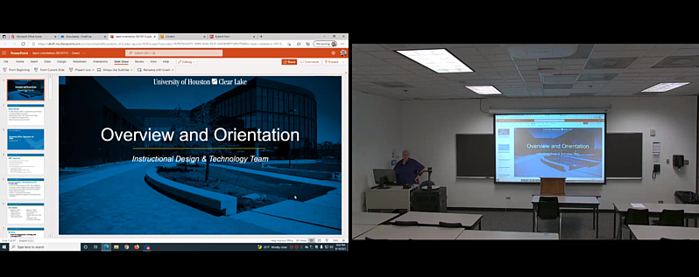
Figure 4. Echo360 Student View

How Do I Adjust the PTZ Settings?
- Locate the touchscreen panel and touch it to activate the system controls.
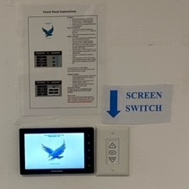
- Press the Projector On button on the panel to power the classroom projector and PTZ camera and automatically lower the screen. NOTE: If you aren't using the screen during the class, you can raise the screen using the screen switch next to the touchscreen panel.
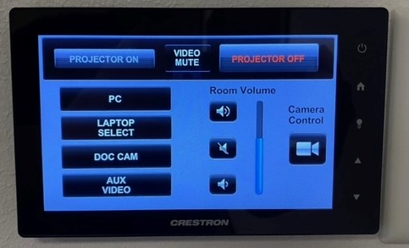
- Click the button under Camera Control on the touchscreen to access the camera's PTZ controls.
- Use the pan, tilt, and zoom controls on the panel to adjust the camera view to your liking. You can also touch Preset 1 to focus the camera on the instructor computer area automatically and Preset 2 to focus on a wide view of the classroom's front wall.
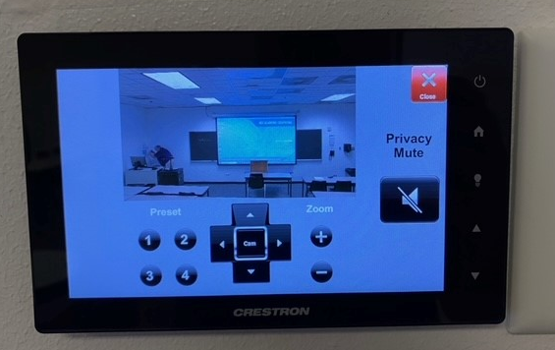
Zoom in
Tilt up
Pan left
- You can use the touchpanel controls to adjust the camera direction throughout your class, as needed.

Need More Help?
For more information about how to use PTZ classroom cameras with Zoom or Echo360, please review our team's support documents Using a PTZ Camera with Zoom and Using a PTZ Camera with Echo360.

For more information about PTZ classroom cameras, don't hesitate to contact the UHCL Support Center, and a member of our OIT staff will be assigned to follow up with you.

Support Center
281.283.2828
supportcenter@uhcl.edu

