Submitting Application Update Form
Steps | Descriptions
Access the UHCL E-Services page at www.uhcl.edu/eservices.
Enter your UHCL network ID and password or your 7 digit ID and password.
Click on the Admissions Tile


Click on the INTL Student Defer Attendance link

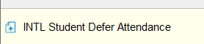

Please Note: If you havent already verified your address and security agreement page, you will see a popup similar to this:
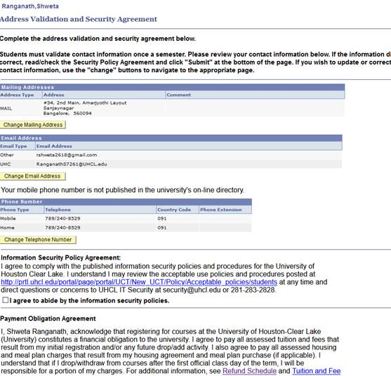

Submit the Agreement and you will have to click on the Student Home button, and then the Admissions Tile again to access the Form.

The first part of the form will determine your eligibility. Select Yes or No to this question
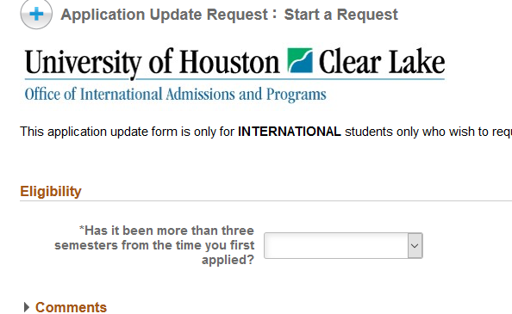

If you select No, the additional form fields that are required will appear:
If you select Yes, it will direct you to complete a new application

 | If you are eligible to complete the form, the system will automatically include your name, ID, and address information. Go to the Application Update section.
If you are updating your semester you can select a term from the lookup
If you are updating your major, you can select a major from the lookup
Complete the section “Have you attended any other college/university since your last applied to UHCL?”
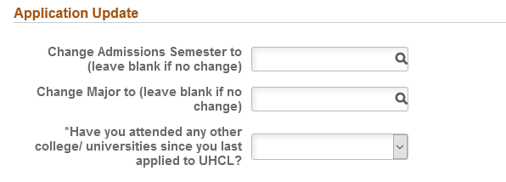

Enter your initials and click on Submit. Once your form has been processed, you will receive an email notification of the decision.
