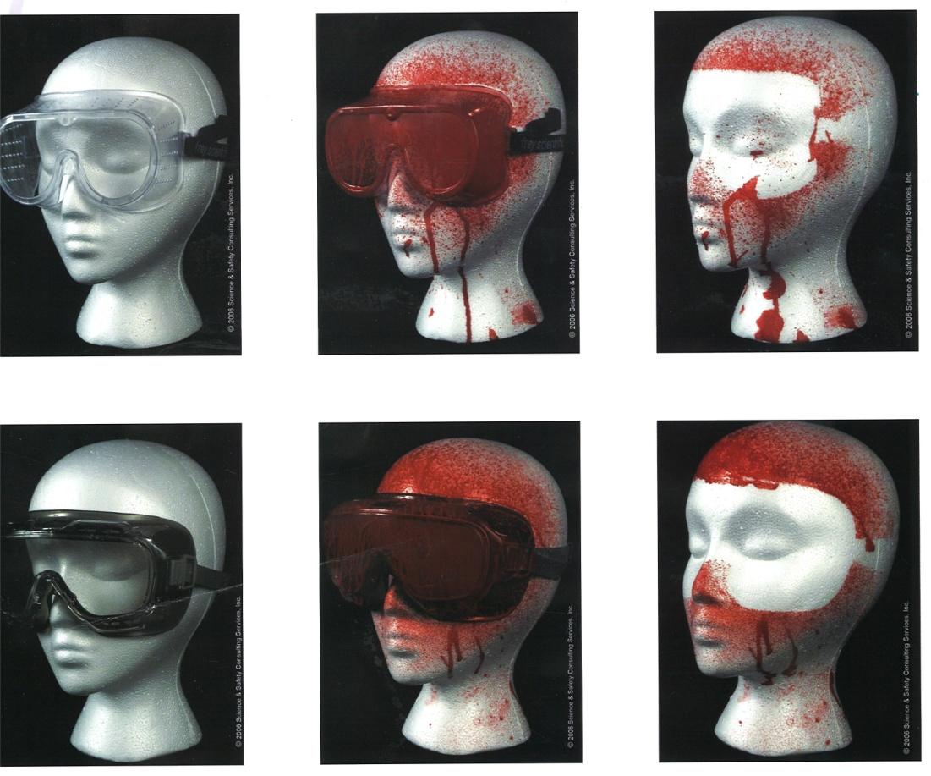
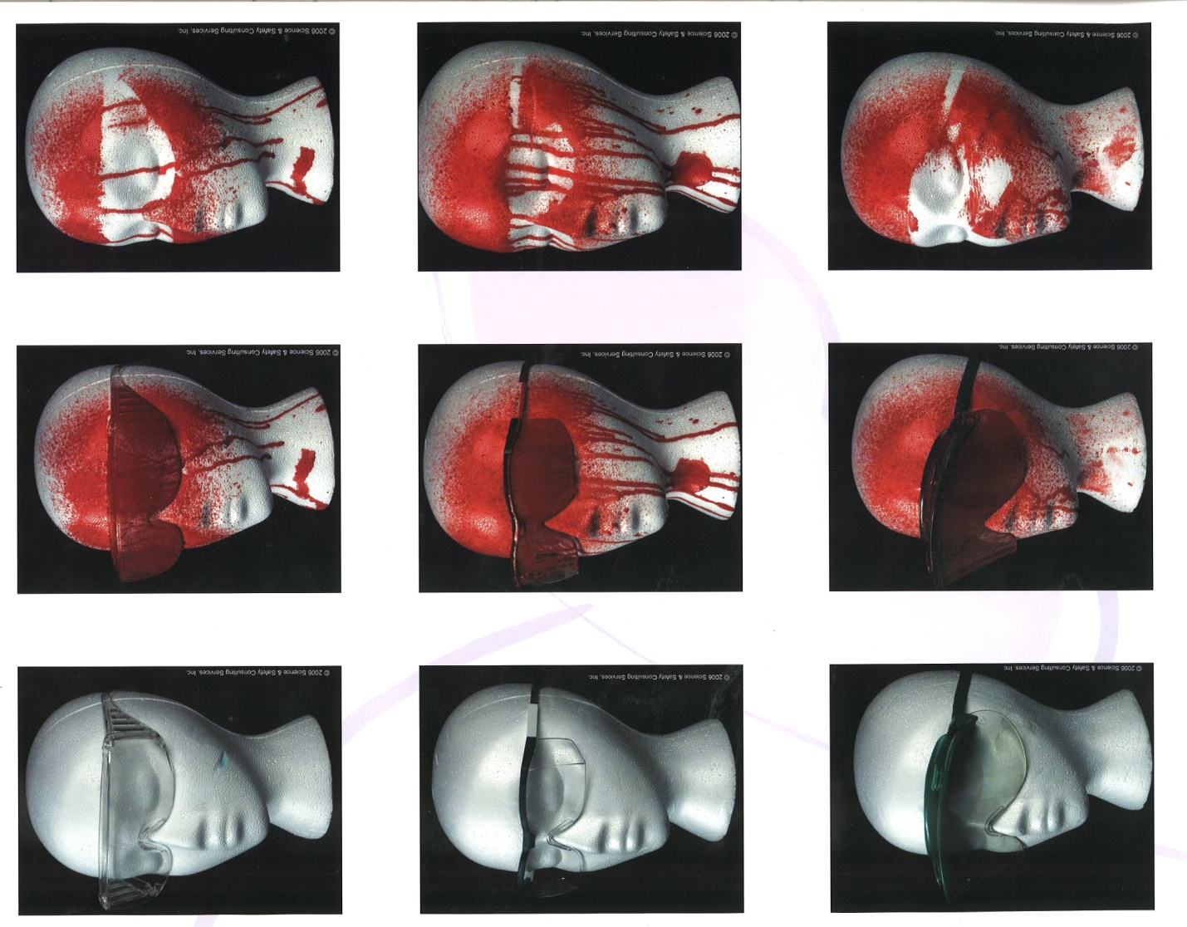
Protective Eyewear and Chemical Splash Protection
These pictures illustrate the amount of protection different eyewear provide. None of the safety glasses pictured here protect the eyes from drips or side spray in the event of a splash to the face. Safety goggles provide the most protection, if the goggles are indirectly vented. Direct vent pinholes still allow chemicals to splash into the eyes.

