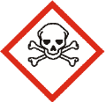
Toxic Hazard Pictograms for secondary containers – prints on Avery 5520 sheet of 30 address labels
Cut and place on containers that already have contents listed, or handwrite contents next to pictogram.

