Dining Dollars Optional Fee – Student Financials
Steps | Descriptions
Access the UHCL E-Services page at www.uhcl.edu/eservices.
Enter your UHCL network ID and password OR your 7-digit PeopleSoft ID and password.

From the Student Home page, click the Finances tile.

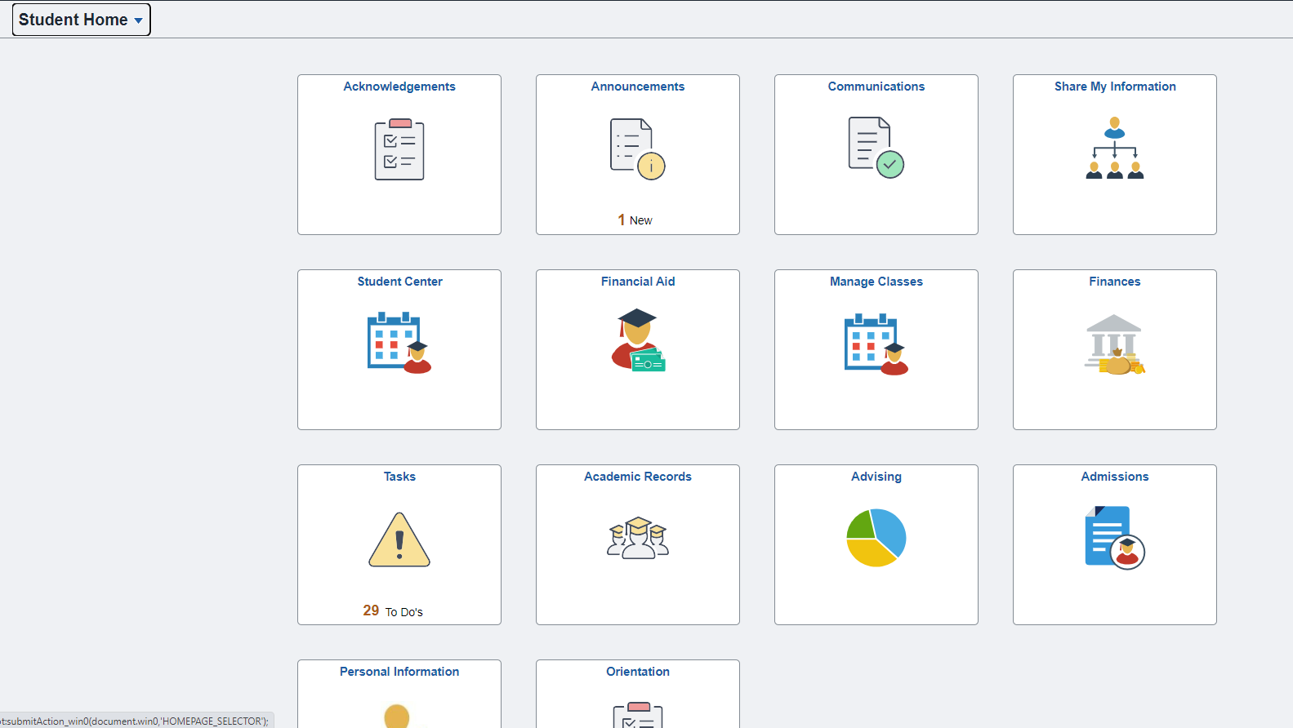

Once in Finances, the Account Balance page will be loaded by default. Click the Optional Fees tile on the left side menu.

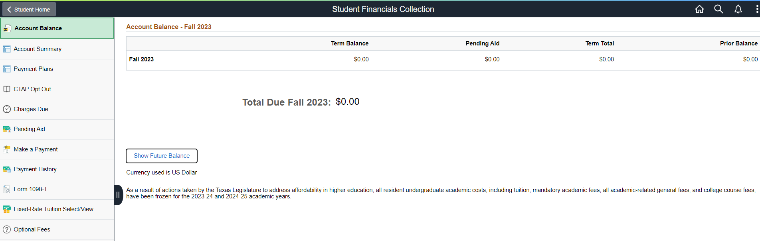

The Optional Fees page is displayed. The Dining Dollars optional fee is available under the current open term. Click the appropriate term.
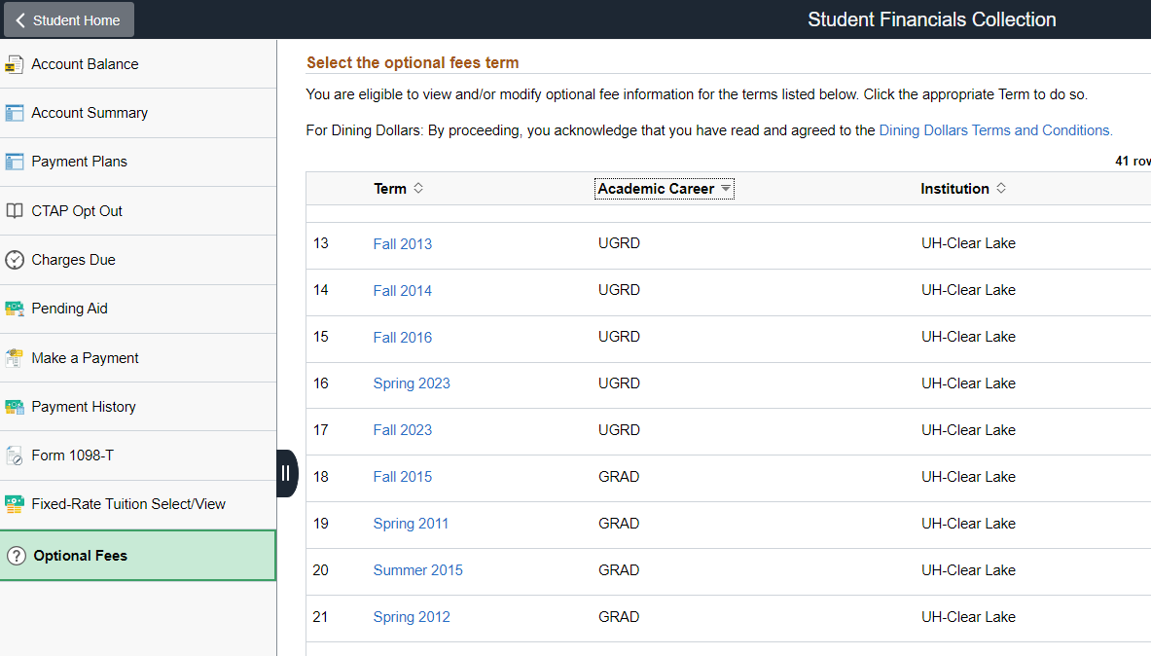

The Dining Dollars optional fee is displayed. Note that the initial value is NONE with Cost of $0.00.
Click the icon to see all valid values.

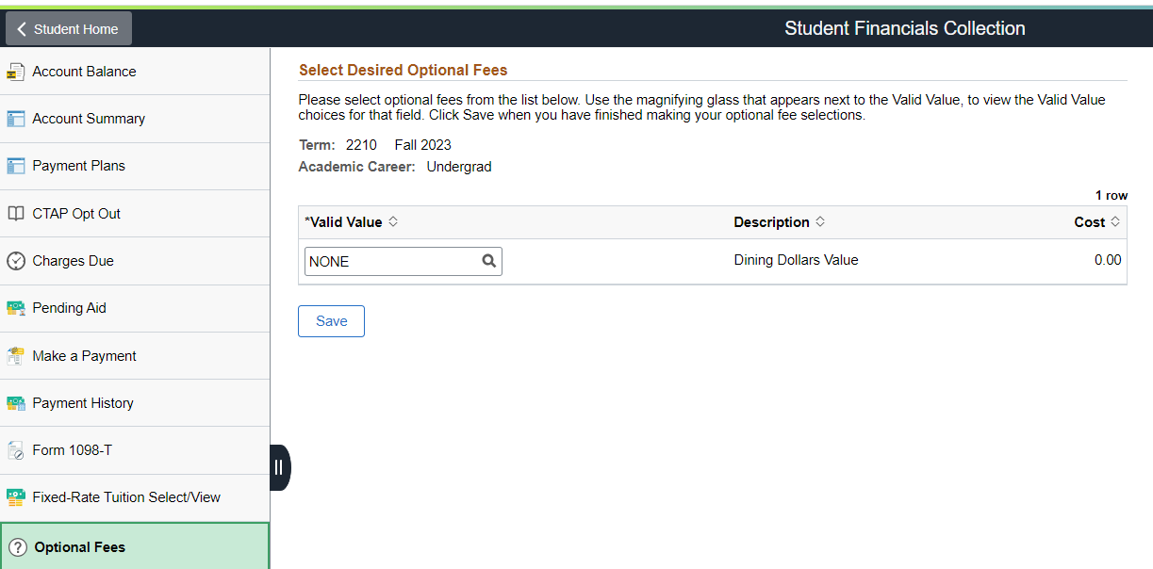

Select the desired Dining Dollars amount (ie. $1600.00)

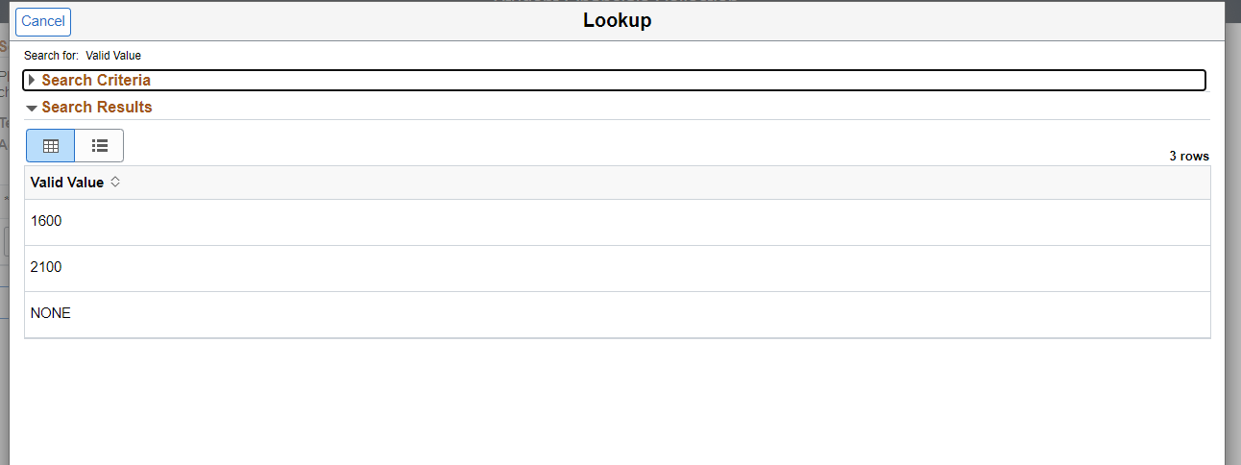

The Cost changes from $0.00 to the selected desired amount (ie. $1600.00). Click the Save button.

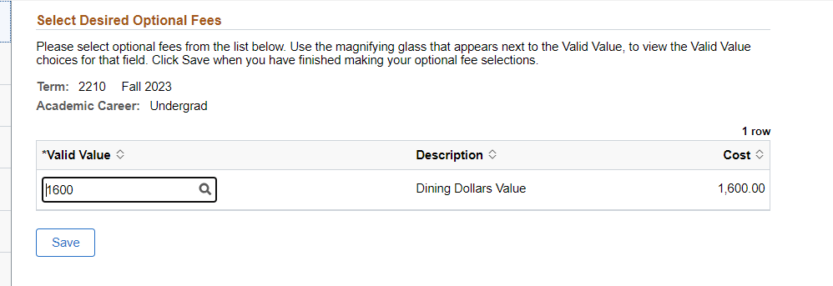

The Dining Dollars optional fee is saved and added to your account.

